

D2D FOOD DELIVERY

Online Food Delivery



A Project Report On

D2D FOOD DELIVERY



**[Red & White Institute of Engineering & Technology](https://www.facebook.com/rnwiet/?hc_ref=ARSE9O7I8-bhy9Weit3stIxUGcMyWJJM-N5UXtTck-6vIxcZc0pgWyqGYxAlNIiQTH4&fref=nf&__xts__%5B0%5D=68.ARA1yiajWdVz_pZeJUhtXbFrnZuiBbZhDtW6zZF8CLlkKl2GgaOWgTXfFFXBfpXDMyuX_zZCSjChjhj_6zi4gNEMixK1Un1Ei9-GKb9EMnke-fr04_BFY7M9apjKLy9D4lvSDfADEvMsY_r-l_rj1m5I-06CwGV7dj33H9RuNfz75YgqtXwfwq4GOTnfQuXCVycDDL9KU-uCUv_AsiTc0vgWW1R_TiTmDPmIMBWjFAnP6g3jrC3rSVOFjEmk7hjwj8qXp9T7mPXB5gCtQaZf9DjNmBy1le2wYGSwqriEh5UBGg9SRcg&__tn__=kC-R)**

**SURAT**

**CERTIFICATE**

This is to certify that the Project report, submitted for the project entitled **D2D Food Delivery** has been carried out by **Mr. Bansi Satasiya(3102), Mr. Hemal Khakhriya (3029), Mr. Sahil Mandani (4118)** at Bachelor of Computer Application of Red & White Institute of Engineering & Technology, Surat for fulfillment of B.C.A degree to be awarded by Rabindranath Tagore University. This Project work has been carried out under my supervision and is to my satisfaction.

**Place:**

**Date:**

|  |  |  |
| --- | --- | --- |
| **Internal Guide** | **Head of the Department** | **External Faculty** |
| **Mr. Piyush Nakarani** (Lecturer, RNWIET**)** | **Mr. Ashish Solanki**  **(**HOD, BCA RNWIET) |  |

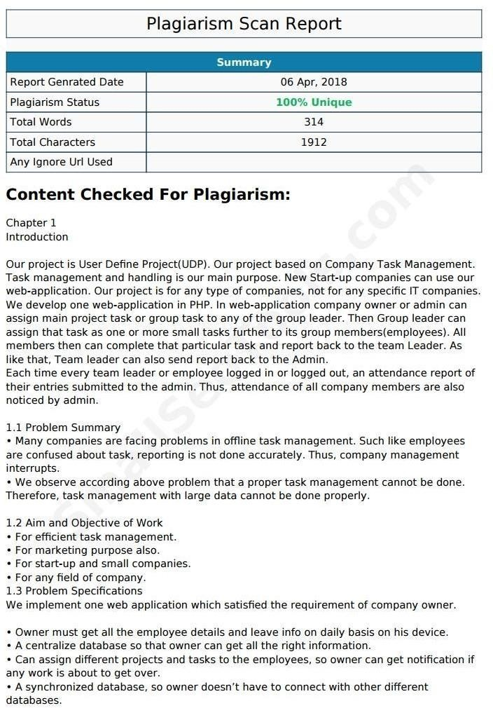

**Red and White Institute of Engineering and Technology**

[UNDERTAKING ABOUT ORIGINALITY OF WORK]

We hereby certify that we are the sole authors of this UDP project report and that neither any

part of this IDP/UDP project report nor the whole of the IDP/UDP Project report has been

submitted for a degree by other student(s) to any other University or Institution.

We certify that, to the best of our knowledge, the current UDP Project report does not infringe

upon anyone’s copyright nor violate any proprietary rights and that any ideas, techniques,

quotations or any other material from the work of other people included in our UDP Project

report, published or otherwise, are fully acknowledged in accordance with the standard

referencing practices.

We have checked the write up of the present UDP Project report using anti-plagiarism database

and it is in the allowable limit. In case of any complaints pertaining to plagiarism, we certify that

we shall be solely responsible for the same and we understand that as per norms, University can

even revoke BCA degree conferred upon the student(s) submitting this UDP Project report, in case

it is found to be plagiarized.

|  |  |  |  |
| --- | --- | --- | --- |
| **Sr. No.** | **Enrolment Number** | **Name** | **Signature** |
| 1. | 9987 | ABC |  |
| 2. | 7878 | PQR |  |
| 3. | 6565 | XYZ |  |

**Place:**

**Date:**

|  |  |  |
| --- | --- | --- |
| **Internal Guide** | **Head of the Department** | **External Faculty** |
| **Mr. Piyush Nakarani** (Lecturer, RNWIET**)** | **Mr. Ashish Solanki**  **(**HOD of BCA) |  |

**Acknowledgement**

The satisfactory that accompanies the successful completion of a project would be incomplete without the people who made it possible. Their constant guidance and encouragement crowned us efforts with success.

We wish to express our sincere gratitude to our guide Lecturer. Anonymous, Red and White Institute of Engineering and Technology, Surat.

We express my profound thanks to Asst.Prof. Ashish Solanki (Head of the Department of BCA), Red and White Institute of Engineering and Technology. We would like to thank them for their continuous support and encouragement.

Without their great knowledge and intelligence, we may not be able to complete this project. Their guidance were very helpful to us to understand the meaning and concept of the topics to achieve the goals of the project. Their suggestions and the way they treated for this project is the best.

Last but not the least, our appreciable also goes to all staff members of the Becholar of Computer Application and to our fellow classmates who directly or indirectly helped us.

BANSI SATASIYA 3102

HEMAL KHAKHRIYA 3029

SAHIL MANDANI 4118

ABSTRACT

The online food ordering system set up menu online and the customers easily places the order with a simple mouse click. Also with a food menu online you can easily track the orders, maintain customer's database and improve your food delivery service. This system allows the user to select the desired food items from the displayed menu. The user orders the food items. The payment can be made online or pay-on-delivery system. The user’s details are maintained confidential because it maintains a separate account for each user. An id and password is provided for each user. Therefore it provides a more secured ordering.

The online food ordering system provides convenience for the customers. It overcomes the disadvantages of the traditional queuing system. This system increases the takeaway of foods than visitors. Therefore, this system enhances the speed and standardization of taking the order from the customer. It provides a better communication platfor

**TABLE OF CONTENTS**

**Abstract …………………………….5**

List Of Figures 6

List Of Tables 7

Chapter 1 8

* 1. Introduction 8
  2. Objective 8
  3. Needs of Online Food Order 9
  4. Existing System 9
  5. Proposed System 10  
       
     **Materials/Tools Required**1.5.1 Hardware Requirement ………………………………………………… 10  
       
     1.5.2 Software Requirement ……………………………………………………10  
       
     **Brief Description Of Technology**1.5.3 HTML ……………..... ……………………………………………………11  
       
     1.5.4 CSS ………………….…………………………………………………....11  
       
     1.5.5 Css Bootstrap………………….…………………………………………...12  
       
     1.5.6 JavaScript ………………….………………………………………………12  
       
     1.5.7 Php ………………….…………………………………………………......13  
       
     1.5.8 My SQL Database ………………….……………………………………...13  
       
     1.5.9 Apache Server ………………….………………………………………….14

Chapter 2

1 System Planning

* 1. Project Implementation & Testing 15
  2. Implementation Issues & Challenges 15
  3. User without background 16
  4. Server performance 16

**2 Development Tools**

* 1. Web Technology 17
  2. Database Environment 17
  3. Project Management Tool 17

Chapter 3   
  
Analysis, Design and Implementation Strategy

* 1. Requirement Analysis Model 18

3.1.1 Software Model 18  
  
3.1.2 Data Flow Diagram ( Context Level ) 19

3.1.3 Use Case Diagram 20  
  
 1. User Use Case Diagram 20  
  
 2. Admin Use Case Diagram 21  
  
3.1.4 ER Diagram 22

3.1.5 Data Flow Diagram (Level 0) 23  
  
3.1.6 Activity Diagram 24

3.1.7 Sequence Diagram 25  
  
3.1.8 Tables Relations Diagram 26

* 1. Data Table Design 27

1. Tbladmin 28
2. Tblcategory 29
3. Tblfood 30
4. Tblfoodtracking 31
5. Tblorderaddresses 32
6. Tblorders 33
7. Tblusers 34

Chapter 4  
  
Modules And Summary Of Results

* 1. Administrator Module 35,36
  2. Customer Module 35,37

**Summary Of Result**

* Features 78

**Conclusion & Future Scope**

1. Conclusion 79
2. Feature Scope 79

List Of Figures

|  |  |  |
| --- | --- | --- |
| **No** | **Figures Name** | **P.No** |
| **1** | Software Model |  |
| **2** | Agile Scrum Framework |  |
| **3** | DFD- Context Level |  |
| **4** | DFD- Level 0 |  |
| **5** | Use Case Diagram |  |
| **6** | Activity Diagram |  |
| **7** | Class Diagram |  |

List Of Tables

|  |  |  |
| --- | --- | --- |
| **Table No** | **Table Name** | **Page.No** |
| **1** | Tbladmin |  |
| **2** | Tblcatagory |  |
| **3** | Tblfood |  |
| **4** | Tblfoodtracking |  |
| **5** | Tblorderaddresses |  |
| **6** | Tblorders |  |
| **7** | Tbluser |  |

Chapter 1

1. **Introduction**

Online food ordering is the process of ordering food from a website .The product can be either ready-to-eat food (e.g., direct from a certified home-kitchen, restaurant) or food that has not been specially prepared for direction consumption (e.g., vegetables direct from a farm/garden, frozen meats. etc).The aim of developing Online Food Ordering system project is to replace the traditional way of taking orders with computerized system. Another important reason for developing this project is to prepare order summary reports quickly and in correct format at any point of time when required.

Online Food Ordering System has a very lot of scope. This PHP project can be used by any restaurants or fast foods for customers for keeping their order records. This project is easy, fast and accurate. It requires less disk space. Online Food Ordering System uses MYSQL Server as backend so there is not any chance of data loss or data security. A customer can choose to have the food delivered or for pick-up.

1. **Objective**

The main objective of this system is to manage the details of item category, food, delivery address, order, and shopping cart. It manages all the information about item category, customer, shopping cart, item category. The project is totally built at administrative end and thus only the administrator is guaranteed the access. The purpose is to build and application program to reduce the managing the item category, food customers. It tracks all he delivery address ordered.

The main objective of this project is to develop an application which gives provision to the restaurant owners to flourish their business by uploading menus at no cost and will invariably lead to higher customer retention and acquisition rates.

1. **Needs of Online Food Order**

Helps customer to order their food at any time. The customers will be able to order their favorite dishes at any point of time, and as we have pointed out earlier, that time is a minimal option, and restaurants must have a specified system through which they can serve a huge number of customers while making their work smoother. Ordering.co is one of the best platforms which provides all of these platforms along with numerous innovative features which has turned countless small and large businesses into an inspiring leader in the online marketplace.

1. **Existing System**

In existing system for giving any orders users should visit restaurants to know about food items and them give order and pay advance.  In this method time and manual work is required. Maintaining critical information in the files and manuals is full of risk and a tedious process.

1. **Proposed System:**

This online application enables the end users to register online, select the food from the e-menu card, read the E-menu card and order food online. By just selecting the food that the user want to have. The results after selecting the food from the E-menu card will directly appear in the screen of the restaurant admin. By using this application the work of the Waiter is reduced and we can also say that the work is nullified. The benefit of this is that if there is rush in the Restaurant then there will be chances that the waiters will be unavailable and the users can directly order the food to the chef online by using this application. The user will be given a username and a password to login.

* Materials/Tools Required
* Hardware Requirement:-
* Ram- 1 GB
* Hard disk - 2GB
* Monitor - SVGA
* Speed – 1.1 GHz
* Software Requirement:-
* Fornt End:- HTML, Css, Javascript, Bootstrap,Css Bootstrap
* Web Server:- Xampp, Apache
* Back End:- Php
* Documention: Ms Word 2007
* Brief Description Of Technology:-

1. HTML:-

* We use HTML Version 5 in our project.
* HTML5 is a markup language used for structuring and presenting content on the World Wide Web.
* It is the fifth and current major version of the HTML standard



1. CSS:-

* We use CSS Version 3 in our project.
* CSS, short for Cascading Style Sheets, is the primary language used to describe look and formatting for webpages across the Internet.
* If you want to work with designing your own web pages, you need to be able to understand and write CSS.



1. Css Bootstrap:-

* We use CSS Bootstrap Version 4.0.0 in our project.

* Provides global CSS settings, fundamental HTML elements styled and enhanced with extensible classes, and an advanced grid system



1. Javascript**:-**

* JavaScript ("JS" for short) is a full-fledged dynamic programming language that, when applied to an HTML document, can provide dynamic interactivity on websites.

* It can be used to control web pages on the client side of the browser, server-side programs, and even mobile applications.



1. Php**:-**

* We use PHP Version 7.2.1 in our project.
* PHP (Hypertext Preprocessor) is a widely-used open source general-purpose scripting language that is especially suited for web development and can be embedded into HTML.



1. My SQL Database:-

* MySQL, the most popular Open Source SQL database management system, is developed, distributed, and supported by Oracle Corporation.
* The MySQL Web site provides the latest information about MySQL software.
* MySQL is a database management system. A database is a structured collection of data.

1. Apache Server:-

* We use Apache Server Version 2.4.29 in our project.
* The Apache HTTP Server Project is an effort to develop and maintain an open-source HTTP server for modern operating systems including UNIX and Windows. The goal of this project is to provide a secure, efficient and extensible server that provides HTTP services in sync with the current HTTP standards.

Chapter 2

System Testing

1. **Project Implementation & Testing :-**

At the end of the system design, it is the beginning for the actual coding to develop the proposed system. During development phase, the table structure of the database will be first built in order to provide a suitable data types that suit the system back end development, system connection and data transfer. Next, the computer side client program will be developed and follow by will be the web services that allow mobile phone client program to communicate with the server and lastly mobile phone side client program will be developed. In testing phase, several test cases will be carrying out to test the system in order to determine the system reliability and system accuracy. According to the test cases, a system testing report will be generated for further review to figure out the system weaknesses and made improvement accordingly. In the deployment phase, several training will be provided for the particular restaurant staff such as how to operate the system, the procedure of handling different event and several instruction that need to be follow when operating the system.

1. **Implementation Issues & Challenges:-**

During the system implementation phase, several challenges need to be confront because it involve end users to test the production system with various situation. The possible challenges may face are as following:

1. **User without background:-**

The users are required to have basic knowledge of how to operate a computer system and android mobile phone in order to use the system. This will be difficulty to give training to the user as the basic knowledge information can be obtained from internet easily.

1. **Server performance:-**

During real time system implementation, three would be a huge number of client that access to the server at the same time. Therefore, it may slow down the connection and performances of the system and even causes the server down if the issue goes beyond the level of acceptance.

* **Development Tools:**

1. **Web Technology :-**

The proposed system is a cross platform system, which include Windows desktop client and Android mobile phone client. Therefore, it require to implement web services in order to support the Android mobile phone client device to fetch data from the database server and store data back to the database server. In this project, WampServer is used to support the issue that mention earlier. WampServer is a Windows web development environment that built-in comes together with the Apache, PHP and MySQL database. Furthermore, PHP will be the programming language that used to create the web services that store in the server and it is able to call by the Android mobile phone client to perform particular task.

1. **Database Environment:-**

The proposed system will need a database system to support in order to store the huge amount of data. MySQL database system will be chosen to support the proposed system because it is well-known open source relational database management system.

1. **Project Management Tool:-**

For the rule of thumb to develop a system, it requires to have an intact system planning which serve as a guide line during the development phases. Microsoft Project is a project management software program and it has been used in the project to design the system planning, project timeline, managing of resources, tracking development progress and etc.

Chapter 3

Analysis, Design and Implementation Strategy

3.1 Requirement Analysis Model

3.1.1 Software Model :-

Requirement

Analysis Analysis

Maintenance

Deployment

Testing

Implementation

System Design

3.2.2 Data Flow Diagram ( Context Level ):-

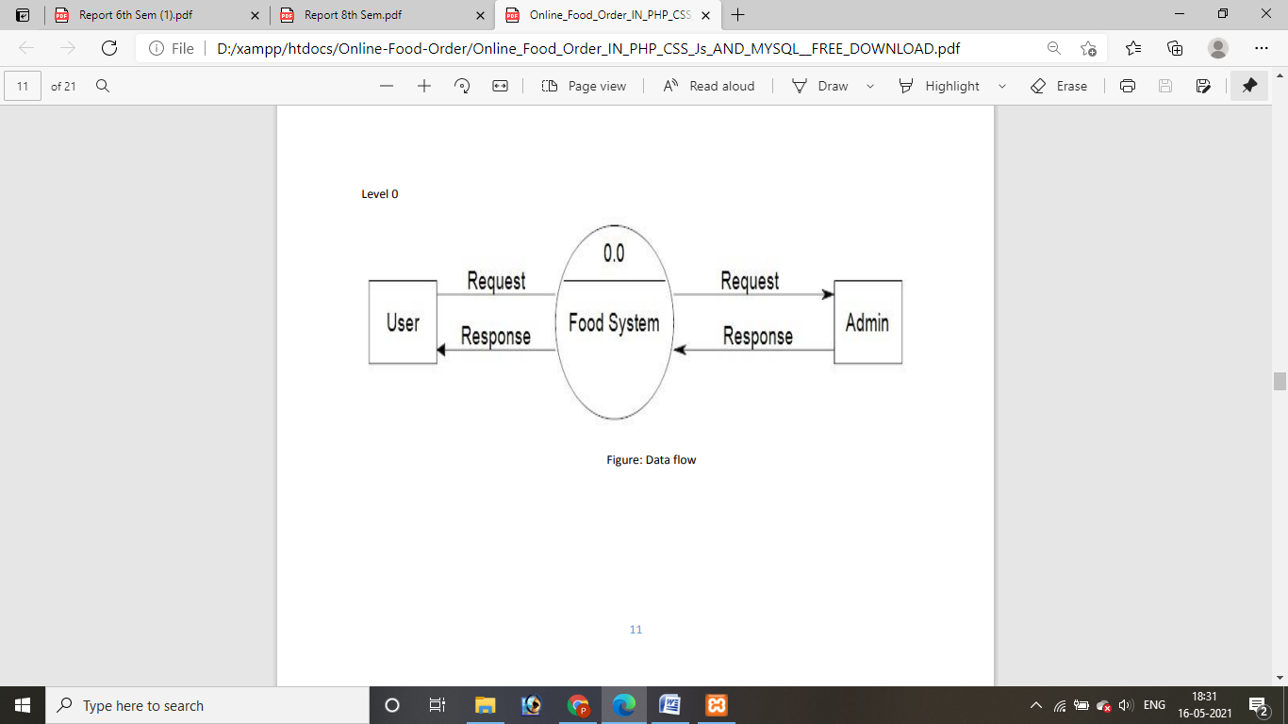

3.2.3 Use Case Diagram :-

A Use case is a description of set of sequence of actions. Graphically it is rendered as an ellipse with solid line including only its name. Use case diagram is a behavioral diagram that shows a set of use cases and actors and their relationship. It is an association between the use cases and actors. An actor represents a real-world object. Primary Actor – Sender, Secondary Actor Receiver.

1. User Use Case Diagram :-

**Update Profile**

**Change Password**

**Order Tracking**

**Place order**

**Sign in**

**Signup**

1. Admin Use Case Diagram :-

**Change Password**

**Update Profile**

**Report Generation**

**Order Management**

**Manage Food Menu**

**Add/ Update**

**Manage Food Categories**

**Add / update**

**Manage Registered Users**

**Dashboard**

3.3.4 ER Diagram :-

The Entity-Relationship (ER) model was originally proposed by Peter in 1976 [Chen76] as a way to unify the network and relational database views. Simply stated the ER model is a conceptual data model that views the real world as entities and relationships.

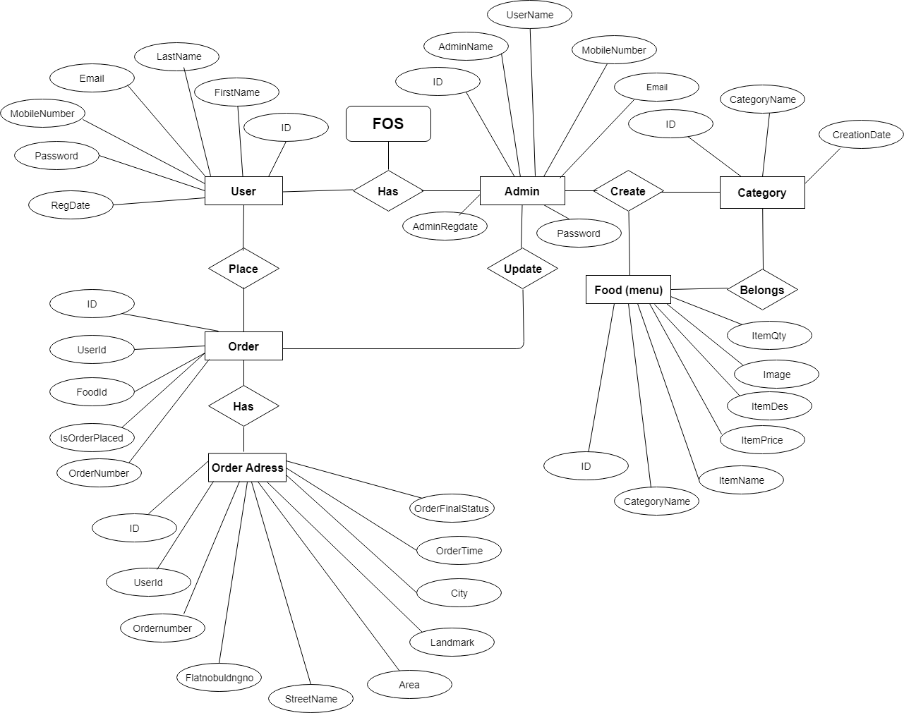

3.3.5 Data Flow Diagram (Level 0) :-

Supplier

Customer

Kitchen

Food

Ordering System

Admin

3.2.6 Activity Diagram :-

Start

Bill Generation

Sign Out

Complete Payment

Deliver Food

Food Preparation

Order Goes To

Home Chef

Input Delivery

Menu Select

Lunch/Dinner

Select

Apply For Meal

Package

Sign In

No

No

End

3.2.7 Sequence Diagram :-

Interface

Admin

Customer

Interaface

1. Login
2. Search Items
3. Order
4. Login
5. Verify The

Customer Order

1. Update Data
2. Manage Restaurants
3. Logout

3.3.8 Tables Relations Diagram :-

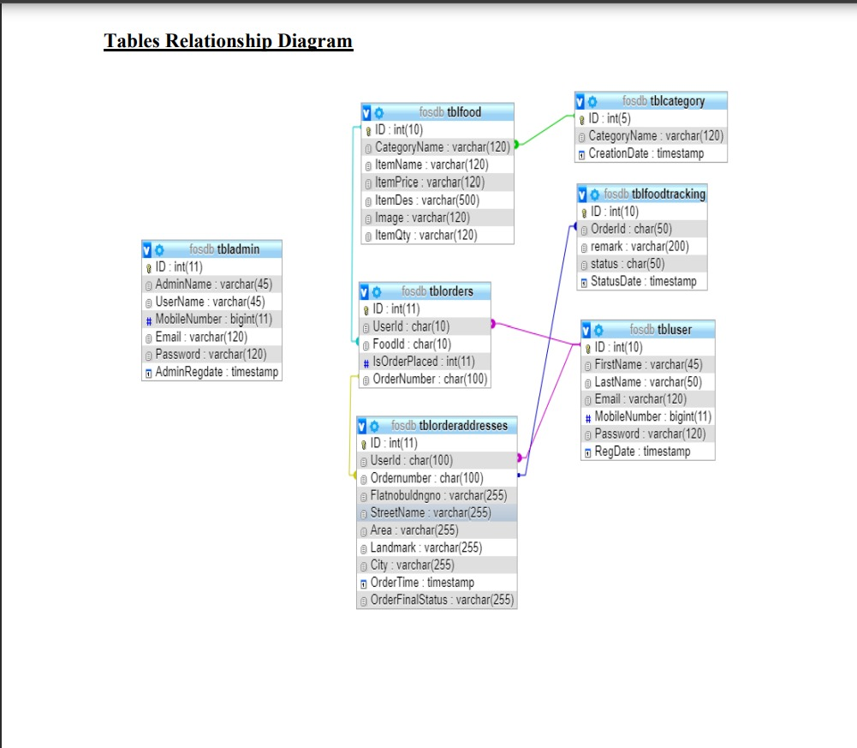3.2 Data Table Design :-

The data in the system has to be stored and retrieved from database. Designing the database is part of system design. Data elements and data structures to be stored have been identified at analysis stage. They are structured and put together to design the data storage and retrieval system.

A database is a collection of interrelated data stored with minimum redundancy to serve many users quickly and efficiently. The general objective is to make database access easy, quick, inexpensive and flexible for the user. Relationships are established between the data items and unnecessary data items are removed. Normalization is done to get an internal consistency of data and to have minimum redundancy and maximum stability. This ensures minimizing data storage required, minimizing chances of data inconsistencies and optimizing for updates. The MS Access database has been chosen for developing the relevant databases.

1. Tbladmin

|  |  |  |  |  |
| --- | --- | --- | --- | --- |
| **No** | **Field** | **Data Type** | **Null** | **Constrain** |
| **1** | Admin Panel | Varchar(45) | Yes | Primery Key |
| **2** | User Panel | Varchar(45) | Yes |  |
| **3** | Mobile No | Bigint(11) | Yes |  |
| **4** | Email | Varchar(120) | Yes |  |
| **5** | Password | Varchar(120) | Yes |  |
| **6** | Admin  regdate | Timestampp | Yes |  |

1. Tblcategory

|  |  |  |  |  |
| --- | --- | --- | --- | --- |
| **No** | **Field** | **Data Type** | **Null** | **Constrain** |
| **1** | Category Name | Varchar(120) | Yes | Primary Key |
| **2** | Creation Date | Timestampp | Yes |  |

1. Tblfood

|  |  |  |  |  |
| --- | --- | --- | --- | --- |
| **No** | **Field** | **Data Type** | **Null** | **Constrain** |
| **1** | Category Name | Varchar(120) | Yes | Primary Key |
| **2** | Item Name | Varchar(120) | Yes |  |
| **3** | Item Price | Varchar(120) | Yes |  |
| **4** | Item Des.. | Varchar(120) | Yes |  |
| **5** | Image | Varchar(120) | Yes |  |
| **6** | Item Quty | Varchar(120) | Yes |  |

1. Tblfoodtracking

|  |  |  |  |  |
| --- | --- | --- | --- | --- |
| **No** | **Field** | **Data Type** | **Null** | **Constrain** |
| **1** | Order id | Char(50) | Yes | Primary Key |
| **2** | Remark | Varchar(200) | Yes |  |
| **3** | Status | Char(50) | Yes |  |
| **4** | Status Date | Timestampp | Yes |  |
| **5** | Order Cancel By User | Int(1) | Yes |  |

1. Tblorderaddresses

|  |  |  |  |  |
| --- | --- | --- | --- | --- |
| **No** | **Field** | **Data Type** | **Null** | **Constrain** |
| **1** | User Id | Char(100) | Yes | Primary Key |
| **2** | Order Number | Char(100) | Yes |  |
| **3** | Flatnobuldgno | Varchar(255) | Yes |  |
| **4** | Streetname | Varchar(255) | Yes |  |
| **5** | Area | Varchar(255) | Yes |  |
| **6** | Landmark | Varchar(255) | Yes |  |
| **7** | City | Varchar(255) | Yes |  |
| **8** | Order Time | Timestampp | No |  |
| **9** | Orderfinalstatus | Varchar(255) | Yes |  |

1. Tblorders

|  |  |  |  |  |
| --- | --- | --- | --- | --- |
| **No** | **Field** | **Data Type** | **Null** | **Constrain** |
| **1** | User Id | Char(10) | Yes | Primary Key |
| **2** | Food Id | Char(10) | Yes |  |
| **3** | Isorderplaced | Int(11) | Yes |  |
| **4** | Order number | Char(100) | Yes |  |

1. Tblusers

|  |  |  |  |  |
| --- | --- | --- | --- | --- |
| **No** | **Field** | **Data Type** | **Null** | **Contrain** |
| **1** | First Name | Varchar(45) | Yes | Primary Key |
| **2** | Last Name | Varchar(50) | Yes |  |
| **3** | Email | Varchar(120) | Yes |  |
| **4** | Mobile Num.. | Bigint(11) | Yes |  |
| **5** | Password | Varchar(120) | Yes |  |
| **6** | Rag date | Timestampp | No |  |

Chapter 4

Modules and Summary of Results

* Modules:-

1. Administrator Module
2. Customer Module
3. Administrator Module:-

Admin can view all the information about the user edit the all details about the customer.

* Create food category
* Manage food categories
* Add food item
* Manage Food item
* Manage user order

1. Customer Module:-

* View product’s list
* Register
* Place orders
* **Admin Module:-**

1. Dashboard: In this section admin can see all detail in brief like total order, not confirmed order, confirmed order, Total food being prepared, Total food pickup, Total food deliver, Total Cancelled orders, and Total user.
2. Reg Users: In this section, admin can manage register user (view/update).
3. Food Category: In this section, admin can manage food category (Add and Update).
4. Food Menu: In this section, admin can manage food menu (Add and Update).
5. Orders: In this section, admin can view the food order details and they have also right to change order status according to current status.
6. Search Order: In this section, admin can search particular order with the help of order number.
7. Reports: In this section, admin can view order details, order counts and sales report according to dates.

* Admin can also update his profile, change password and recover password
* **User Module:-**

1. Food Menu: In this section user can view which food available in restaurants
2. My Accounts: In this section user can his/her password, view and update his/her profile and logout from accounts.
3. My orders: In this section, user can view order history after login.
4. Cart: In this section, user can add their food, which he/her want to order.
5. User has also a facility to download his/her invoice and cancel order if he/her wants to cancel.

.

* Screenshot :-

1. Home Page  
     
   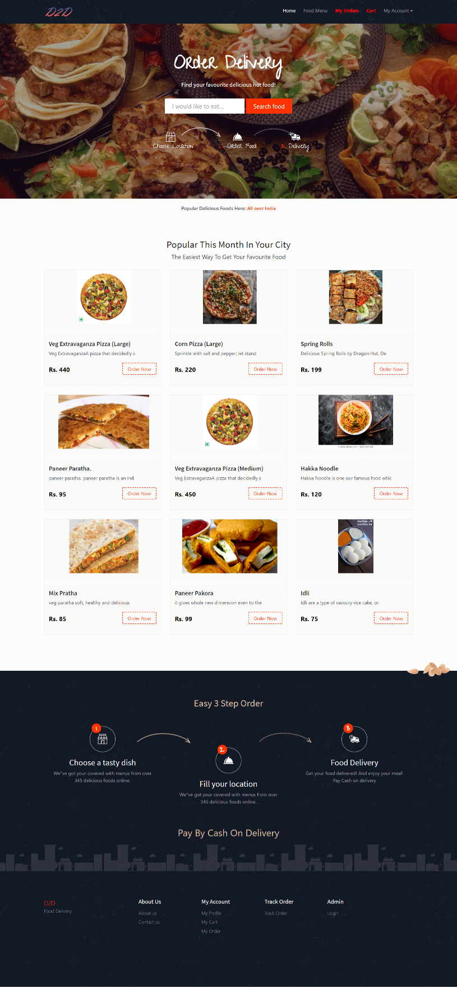
2. Food Menu

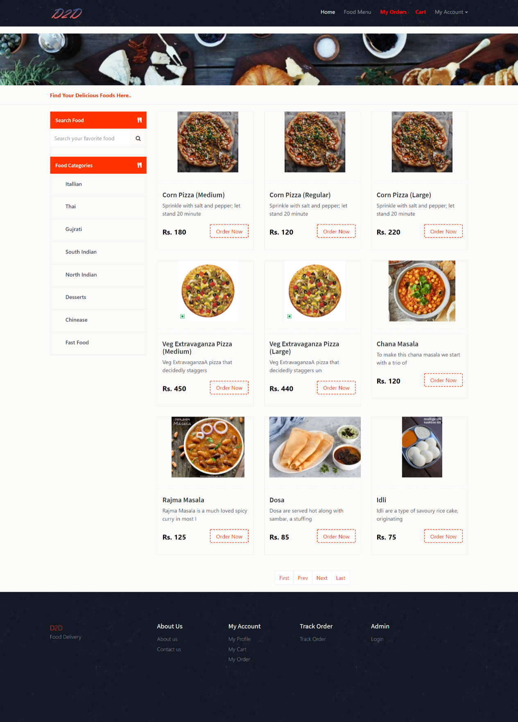

1. Sign Up Page

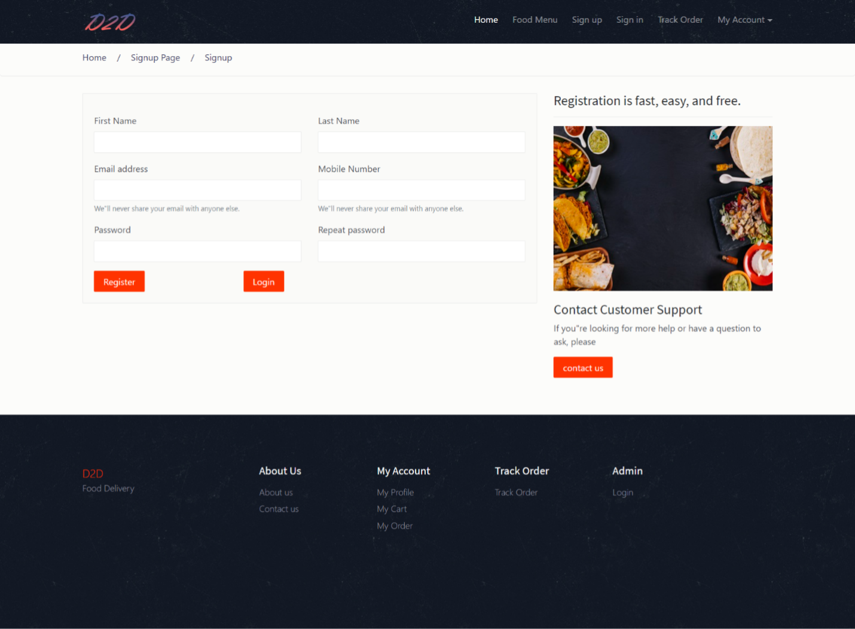

1. Login Page

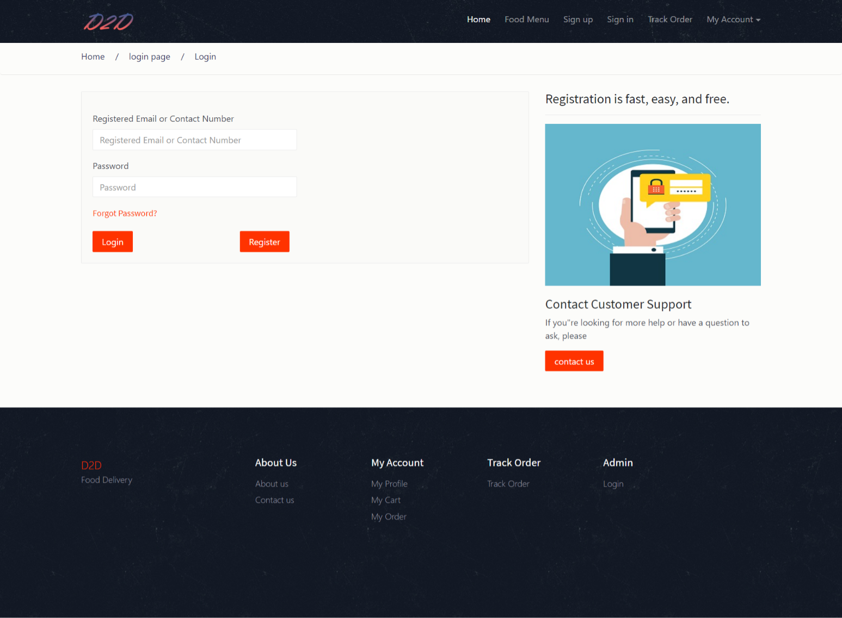

1. My Order Page

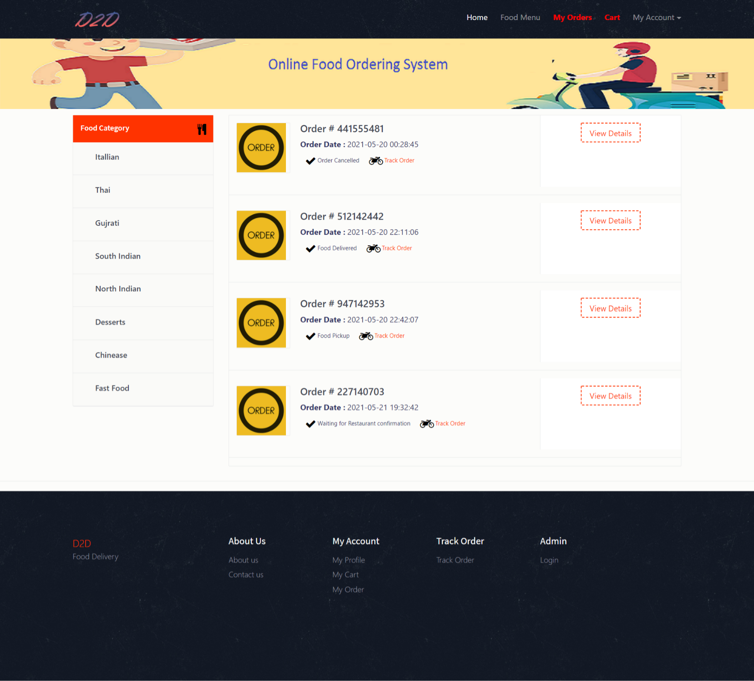

1. Order Details Page

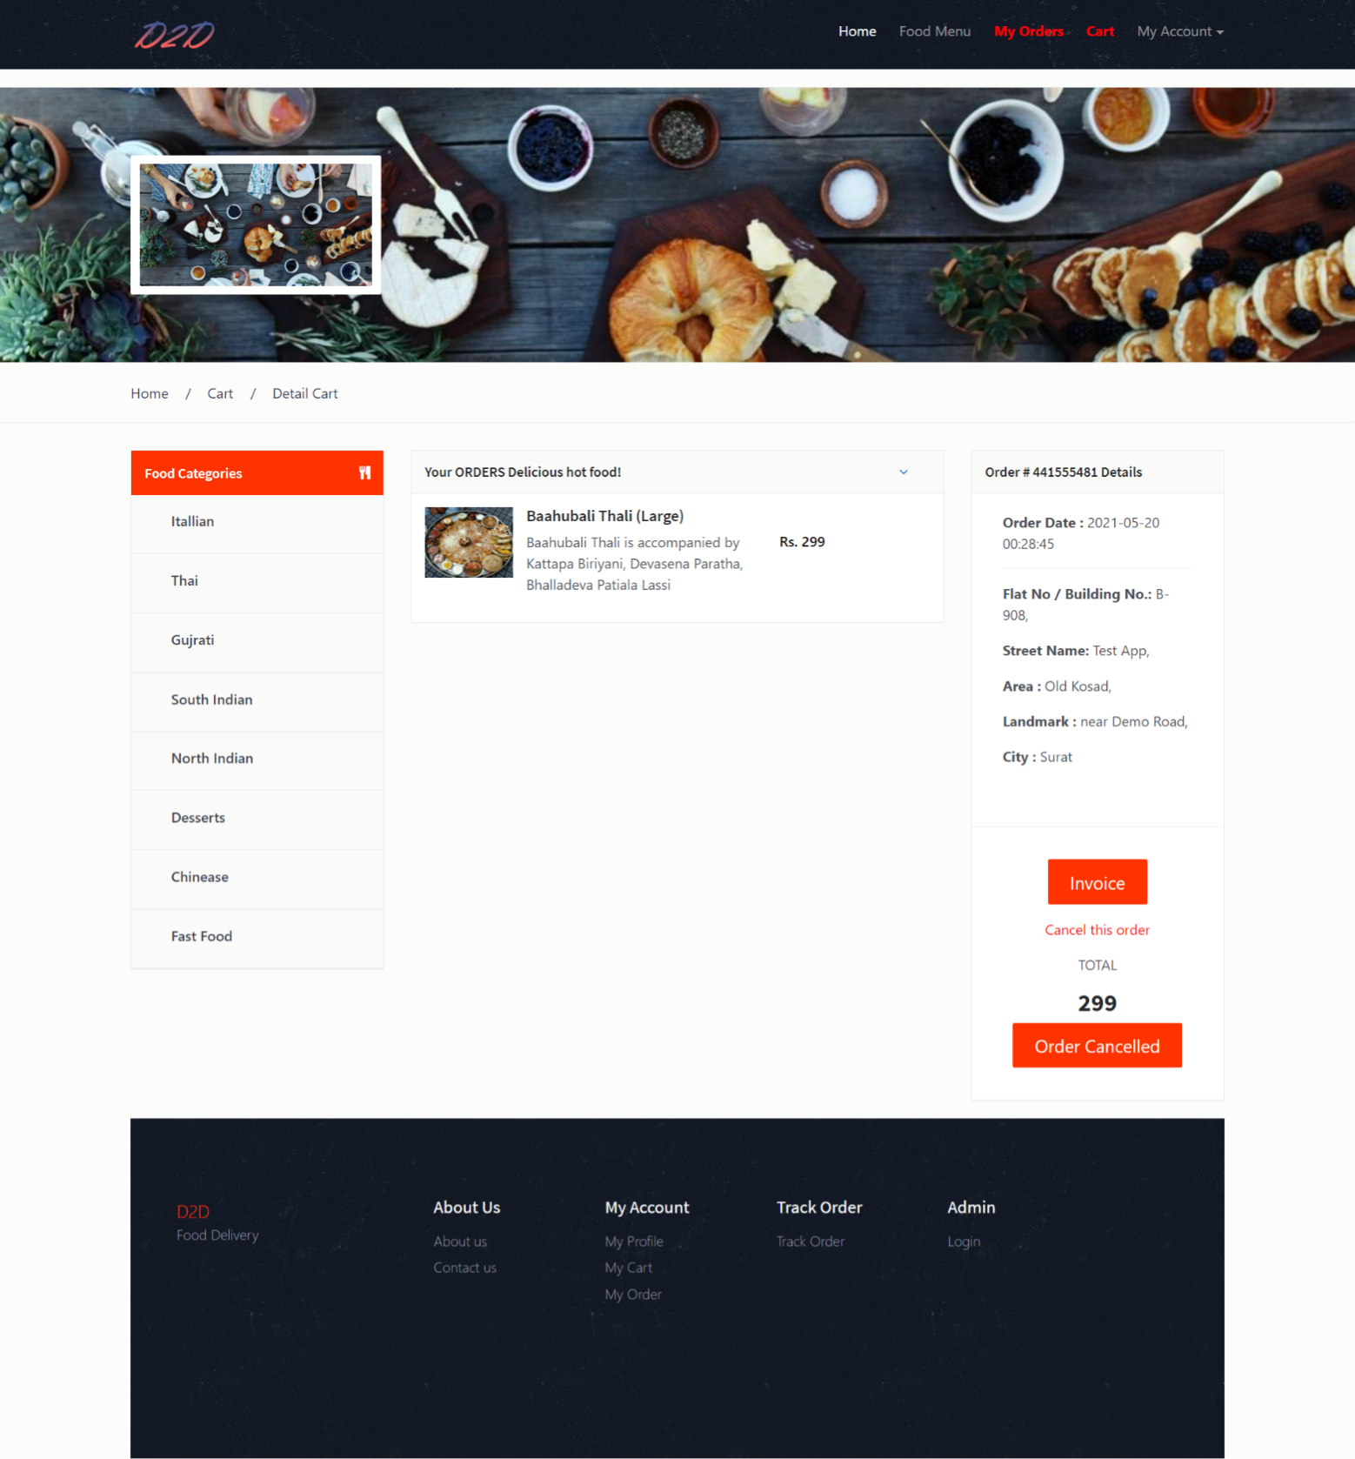

1. Invoice Of Order

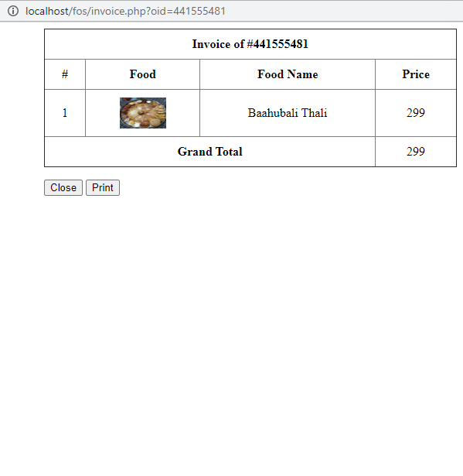

1. Print In Voice

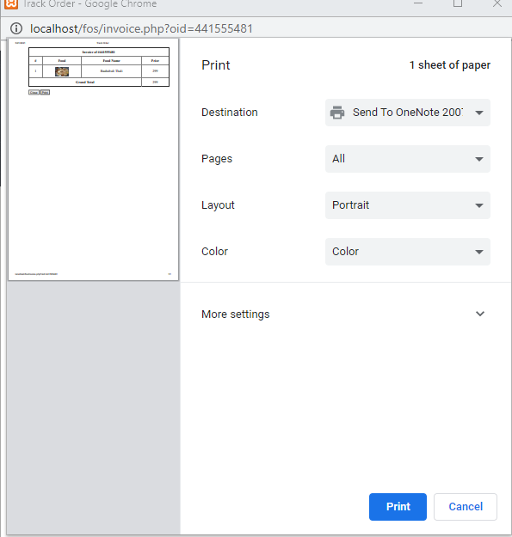

1. Cart Detail

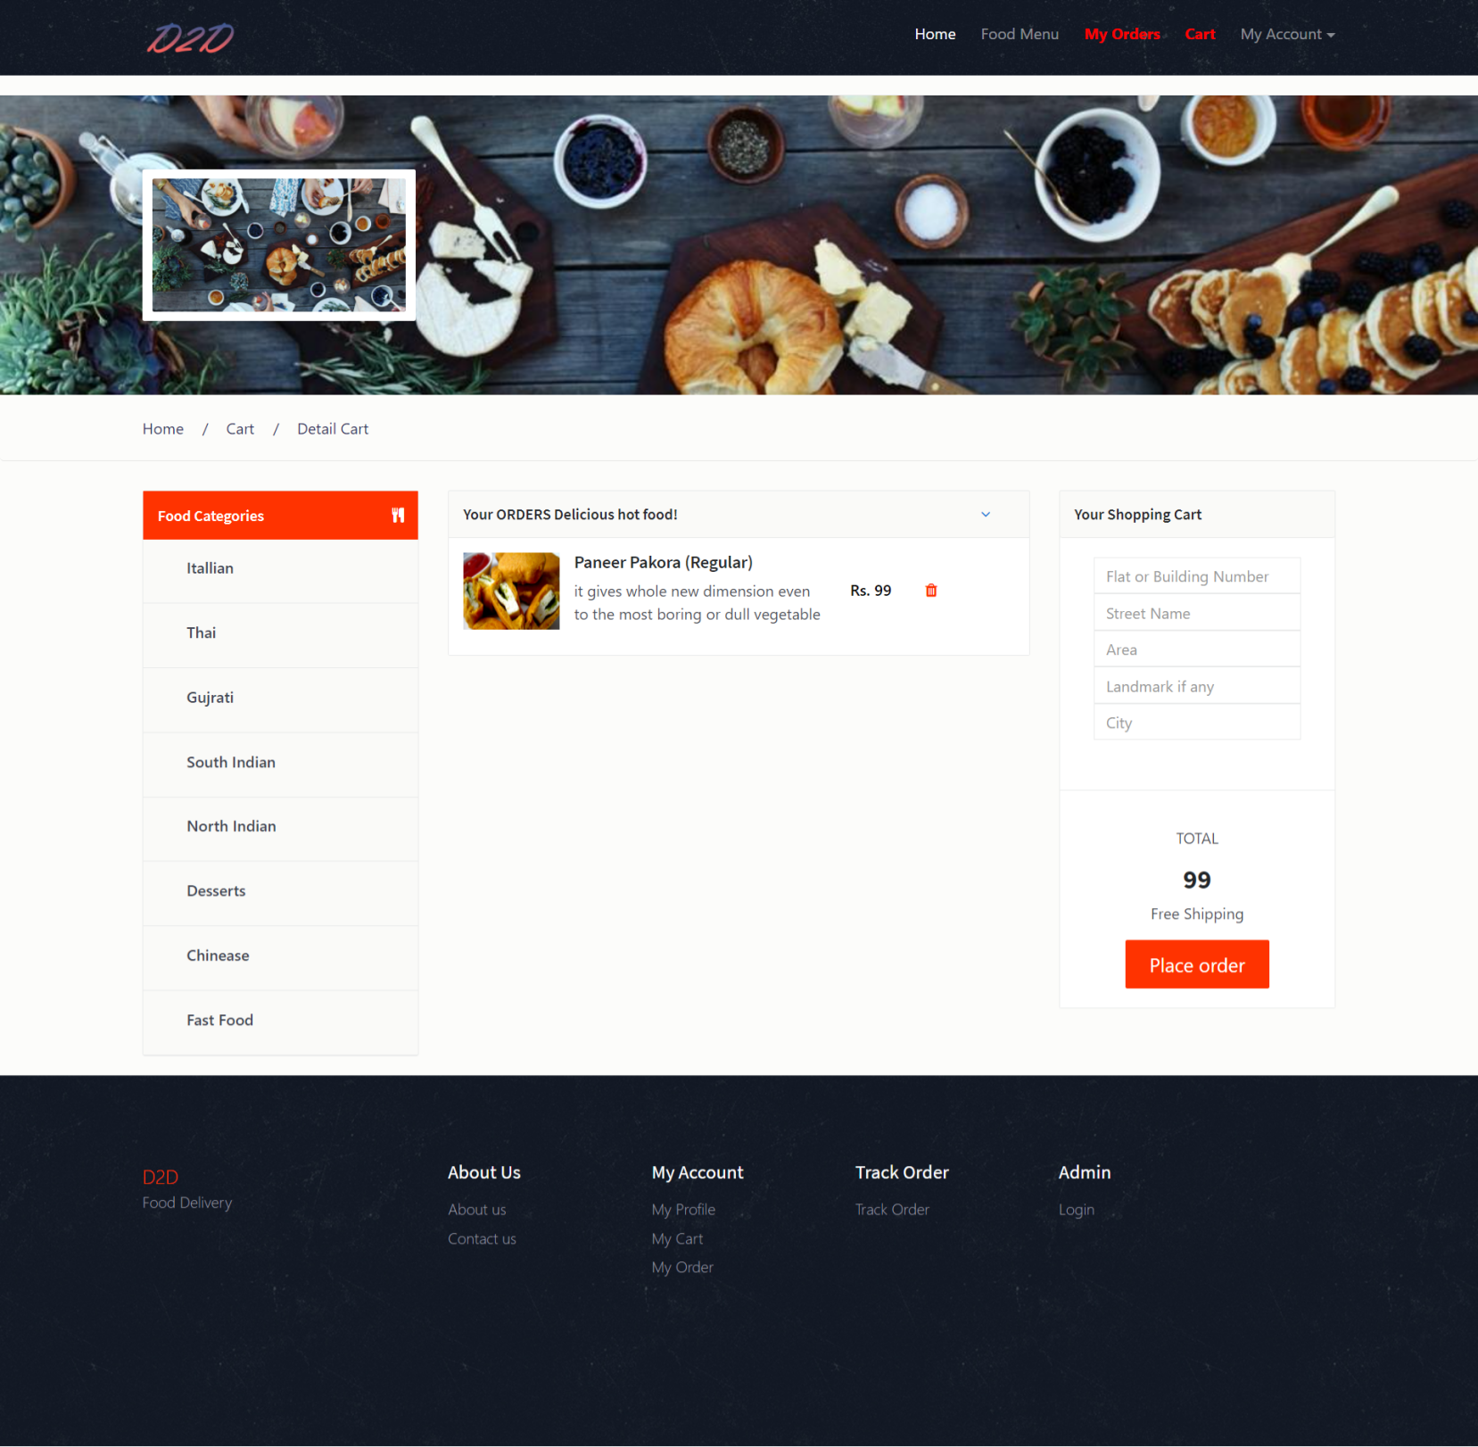

1. Track Order

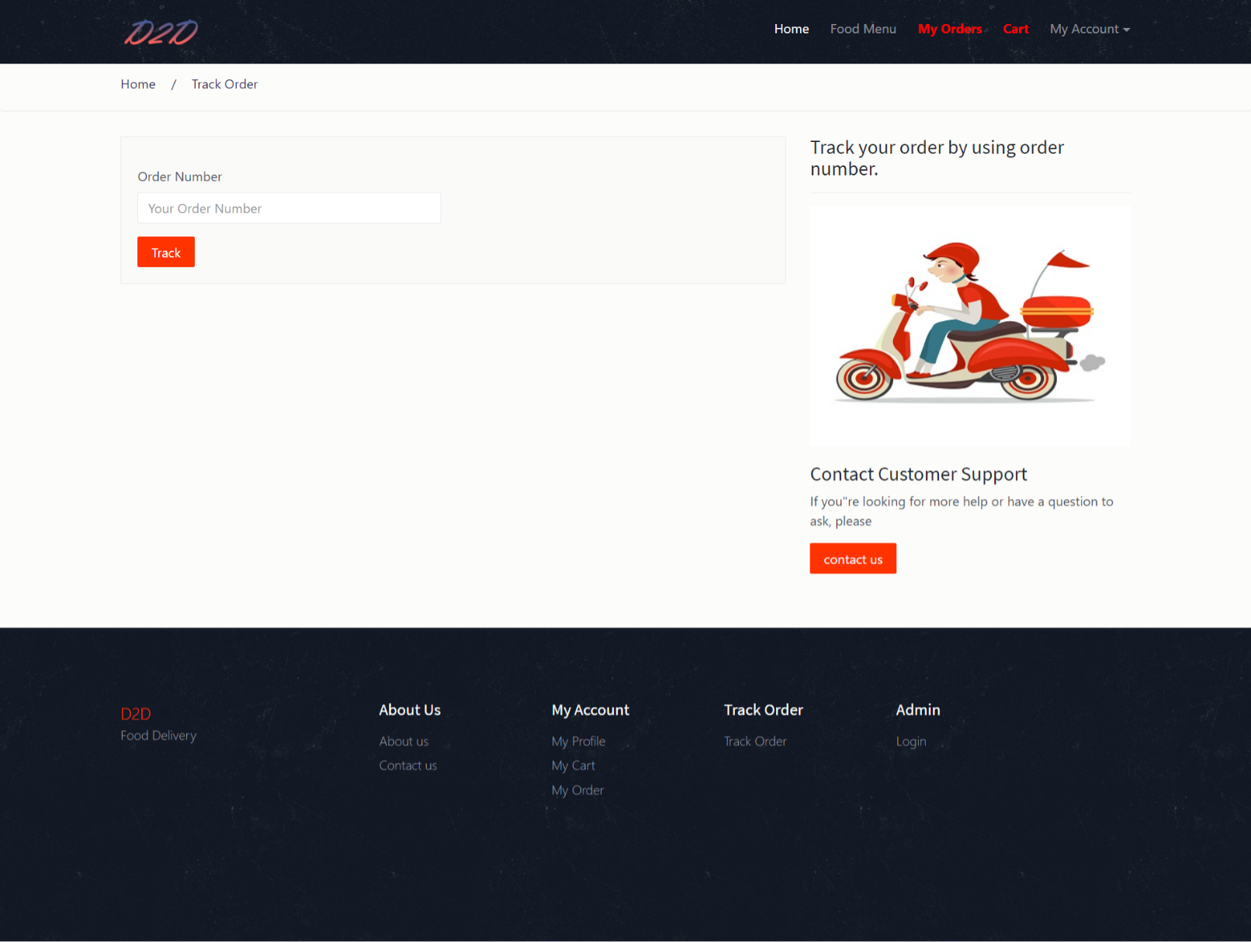

1. Change Password

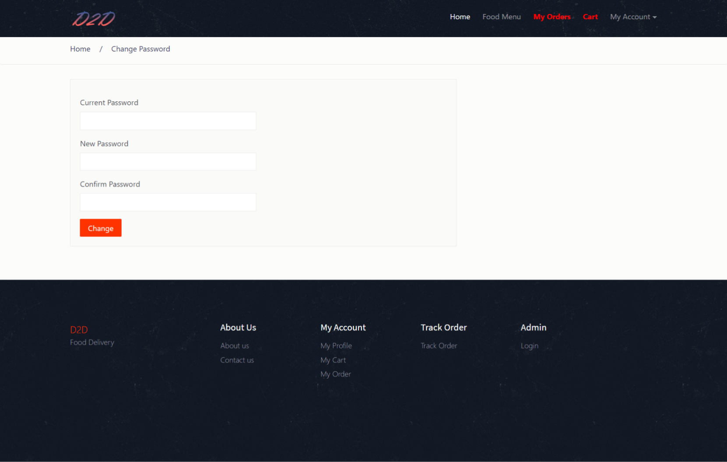

1. User Profile

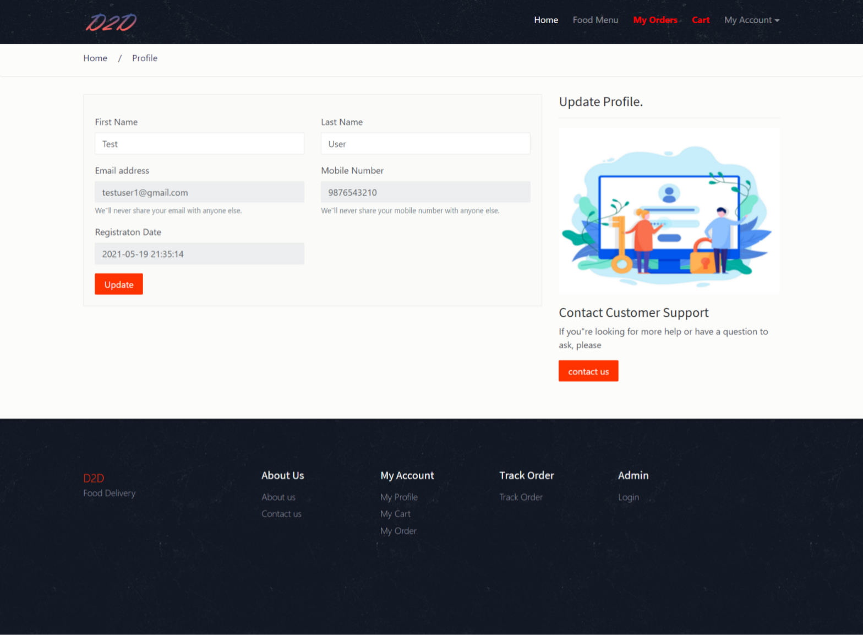

1. Forgot Password

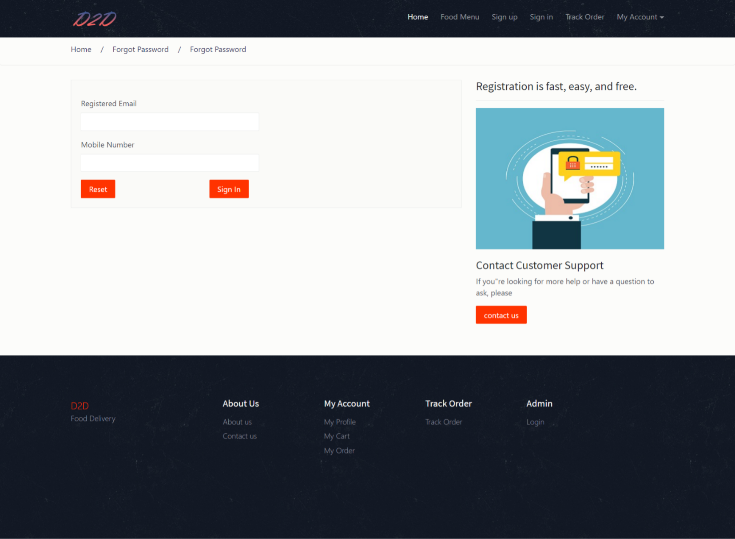

14. Reset Password

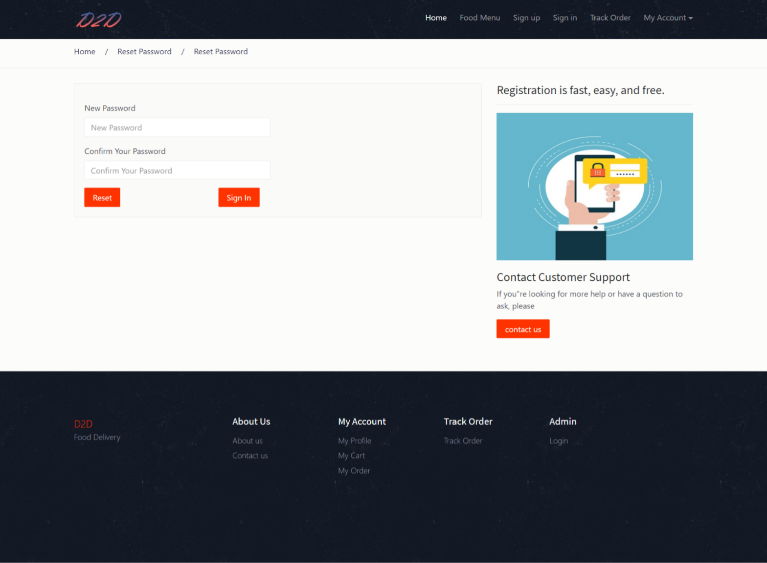

**Output Screen of Admin Side**

1. Admin Login

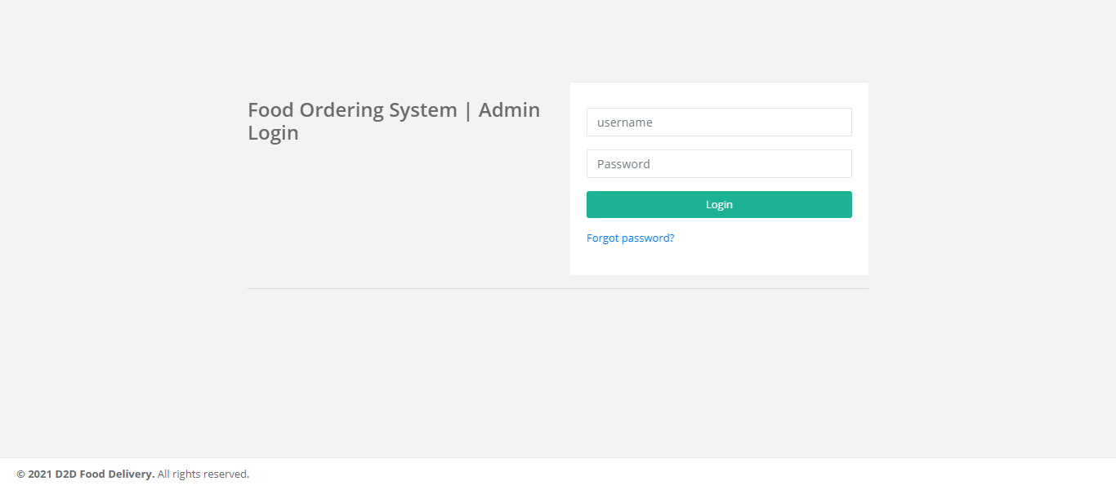

1. Admin Profile Page

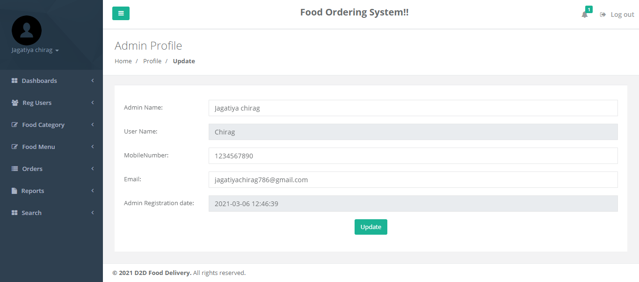

1. Change Password

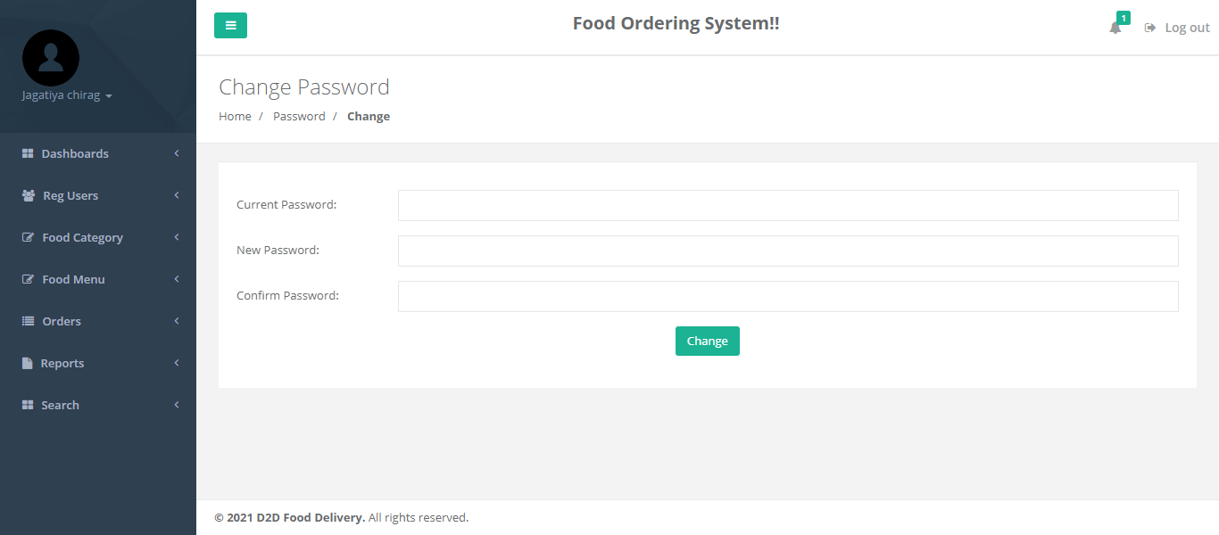

1. Admin Dashboard

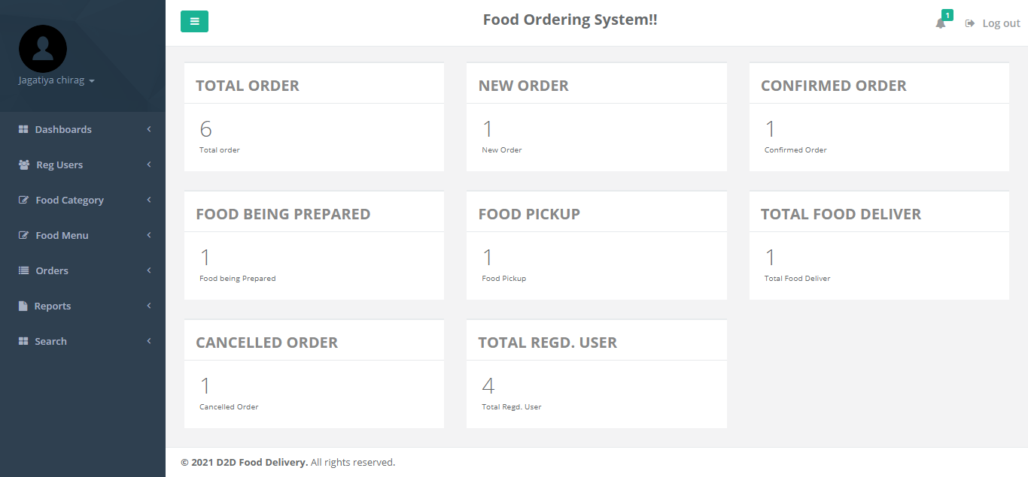

1. Users Details

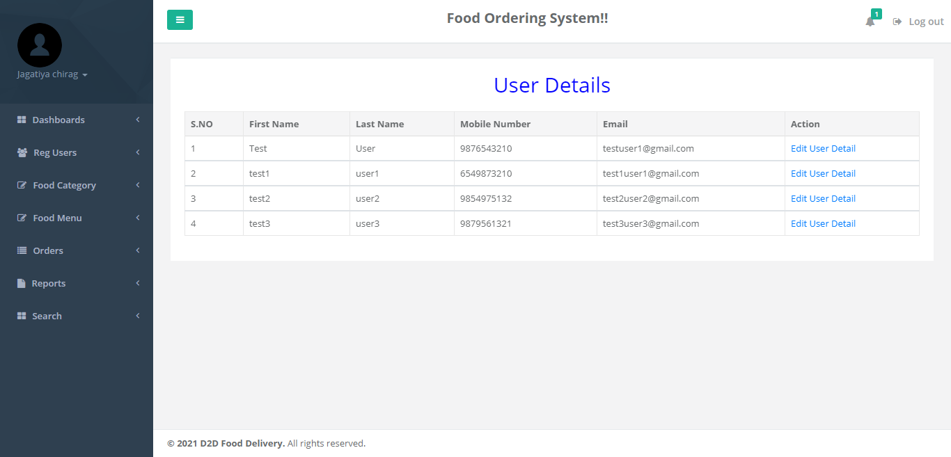

1. User Detail Edit Page

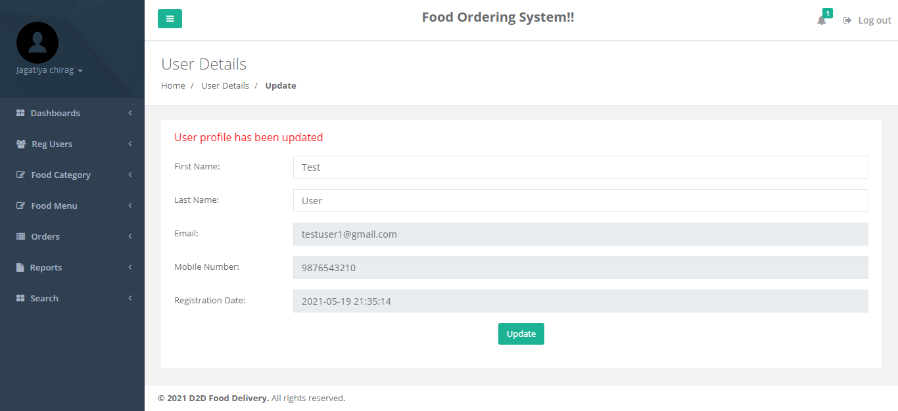

1. Add Food Category

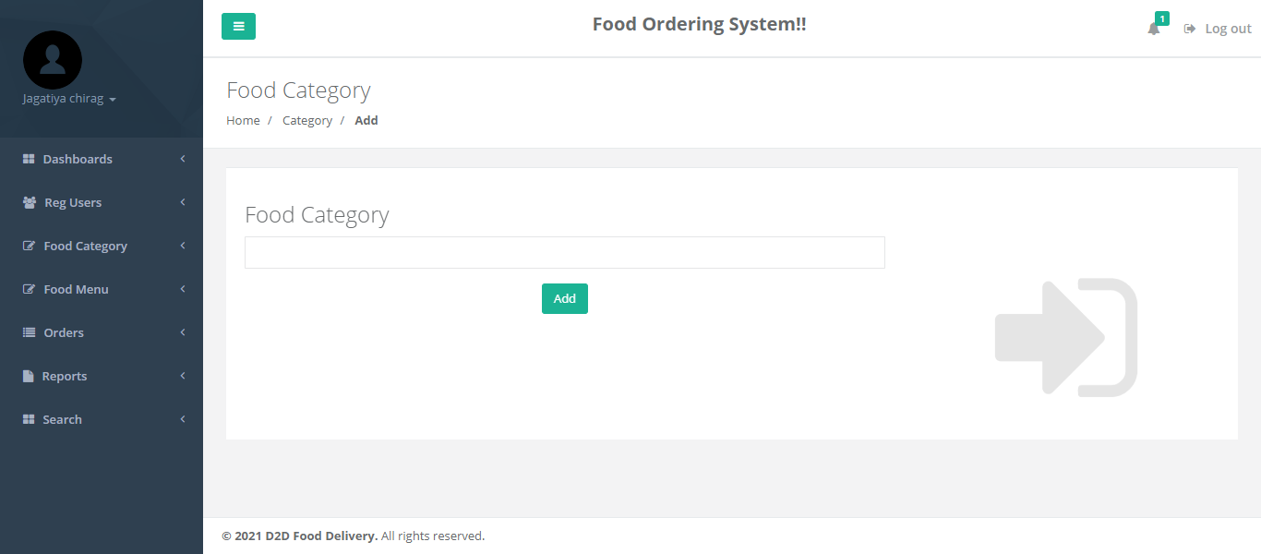

1. Manage Food Category

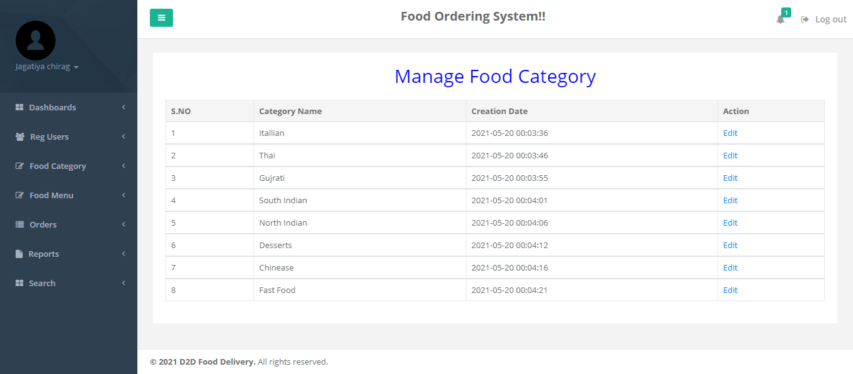

1. Edit Food Category

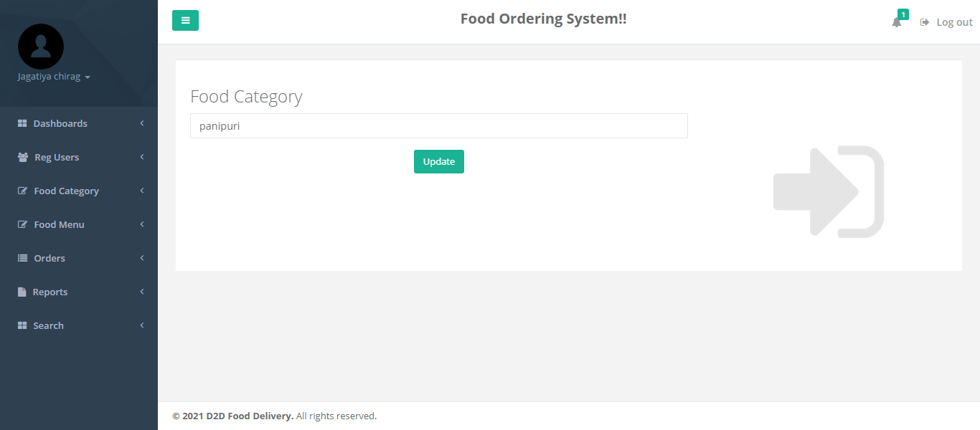

1. Add Food Items

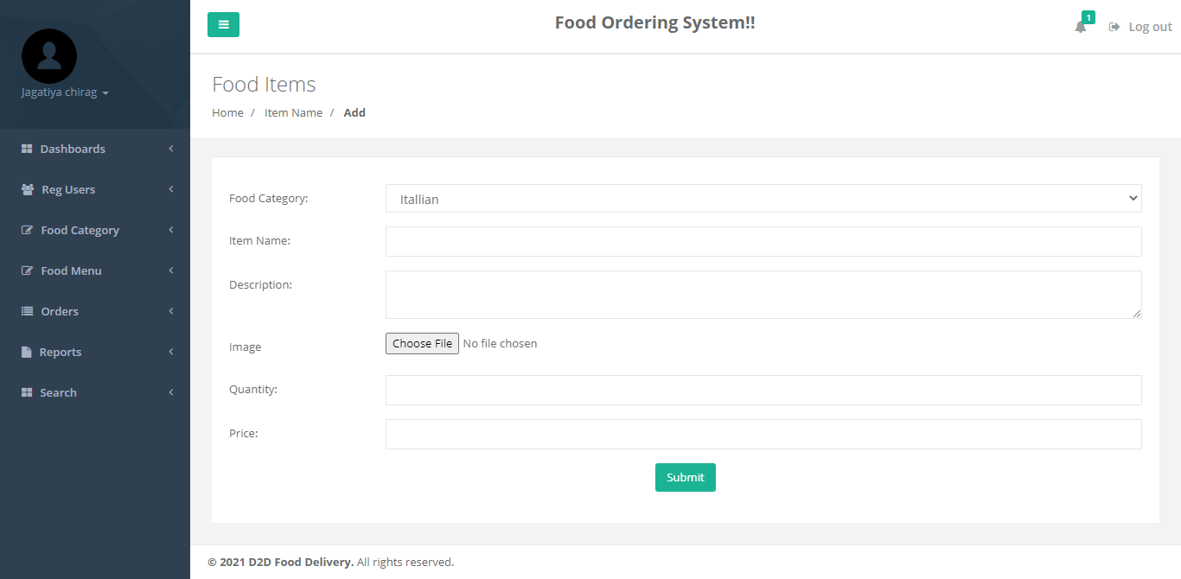

1. Manage Food Items

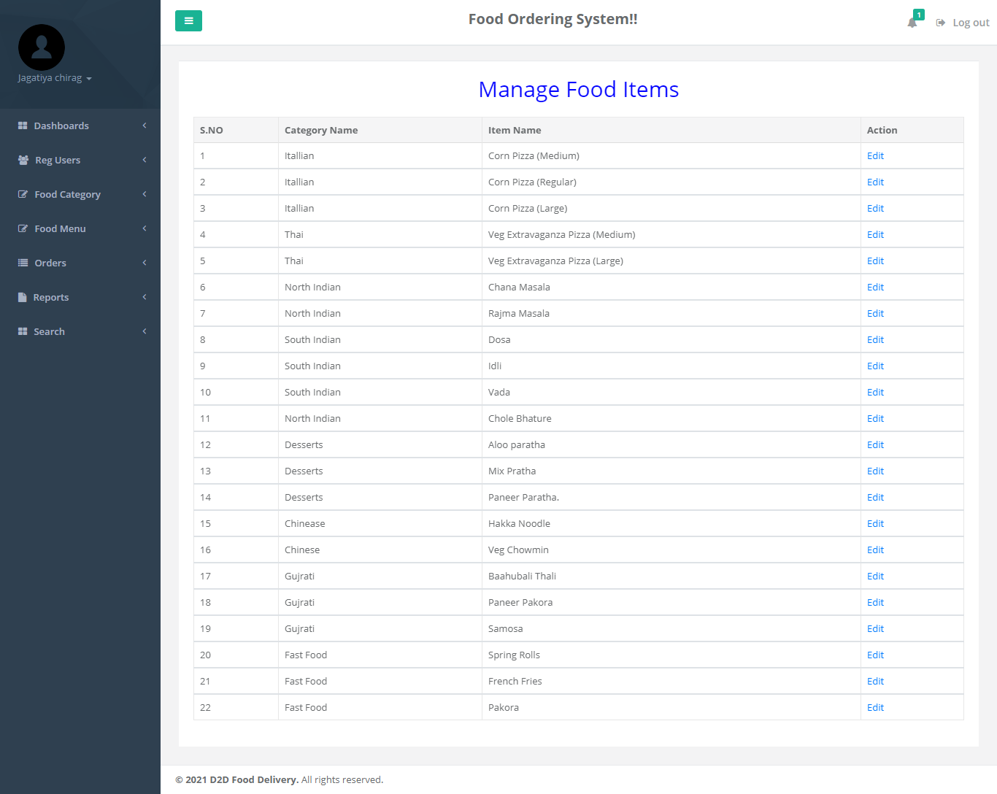

1. Edit Food Items

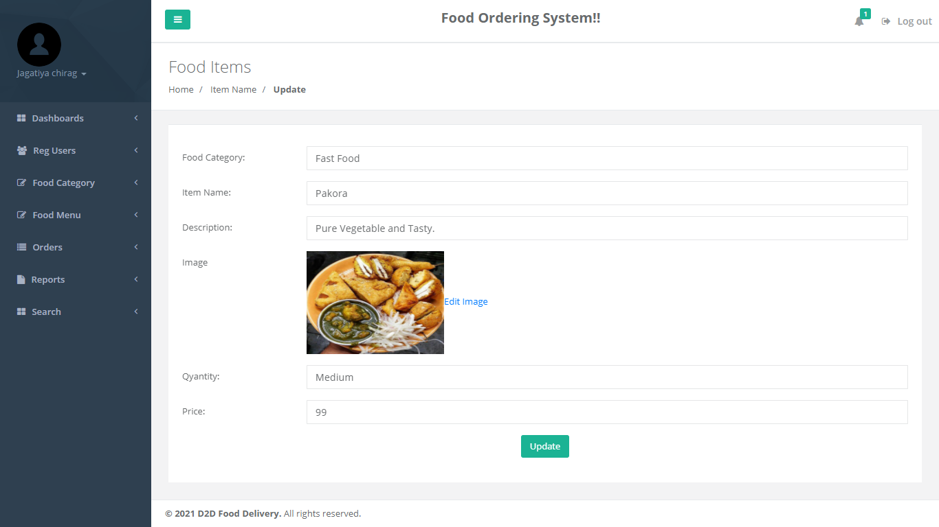

1. Update Image

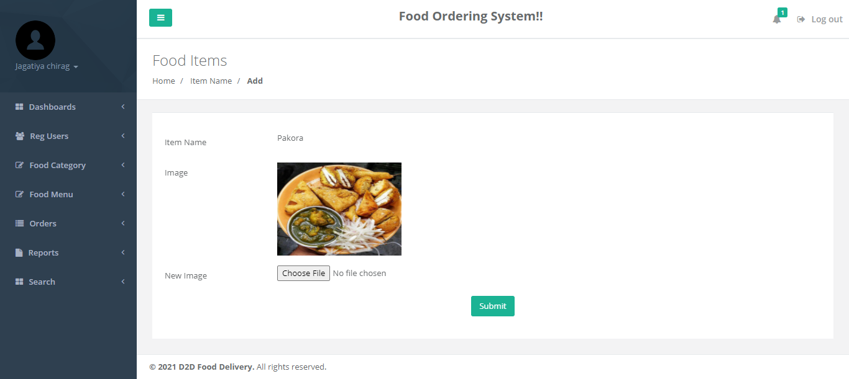

1. Not Confirmed Order

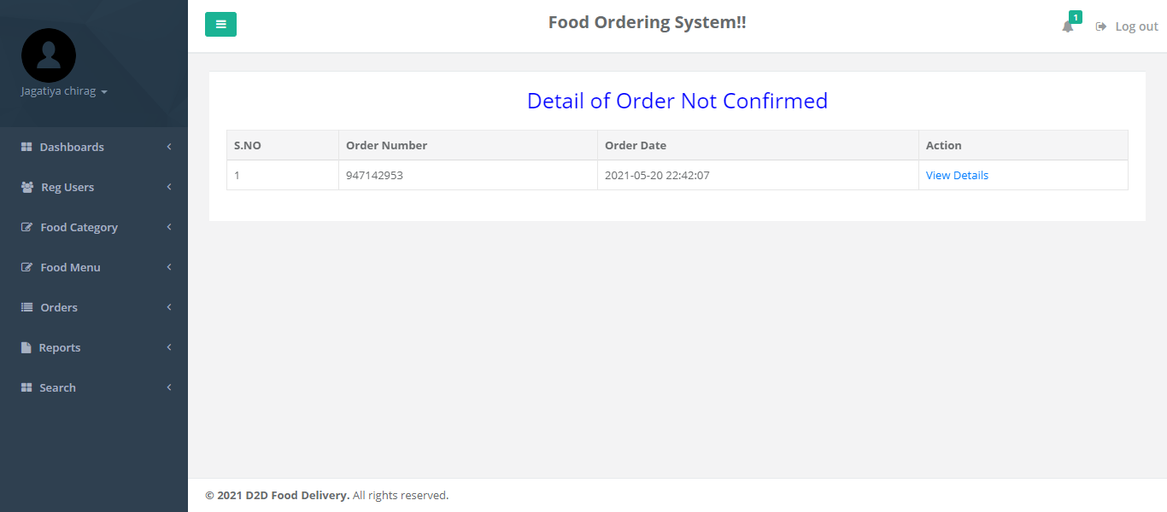

1. Detail of Confirmed order

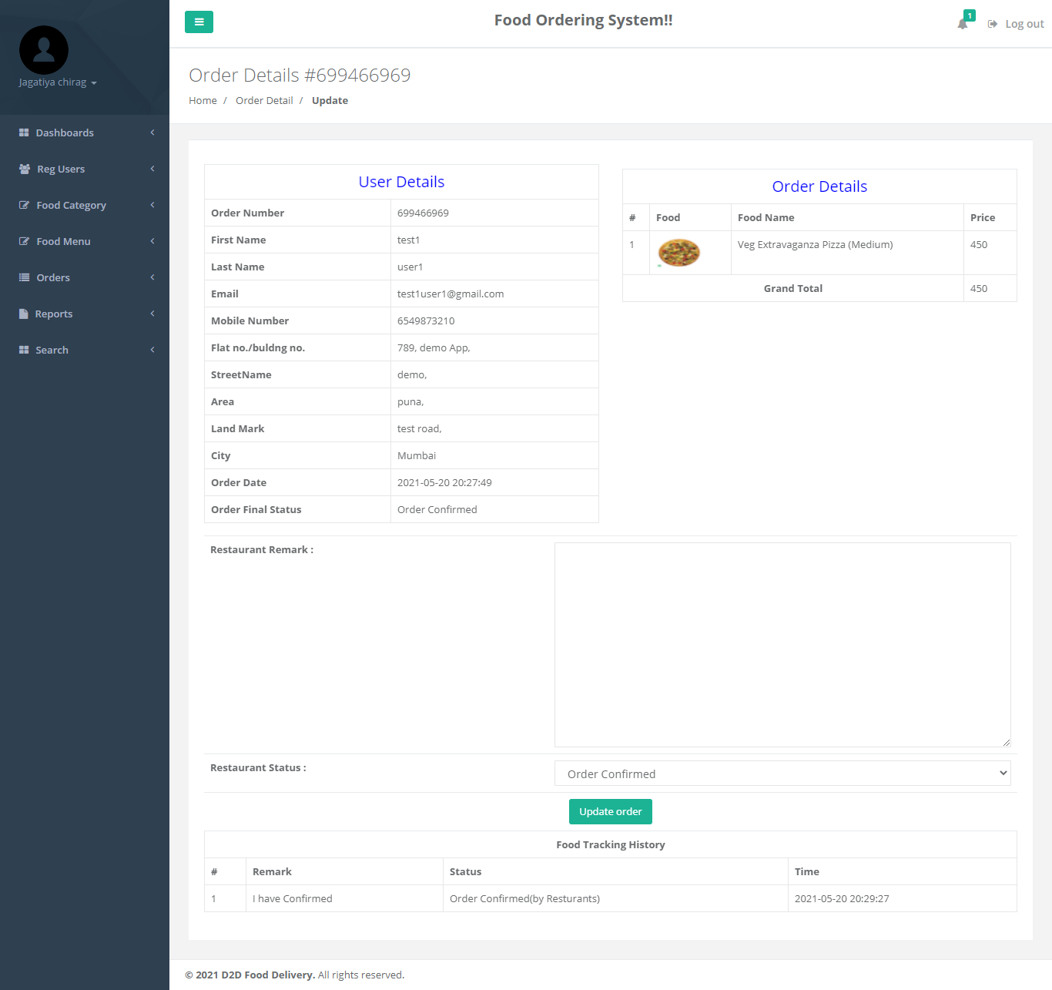

1. Detail Of Order Received

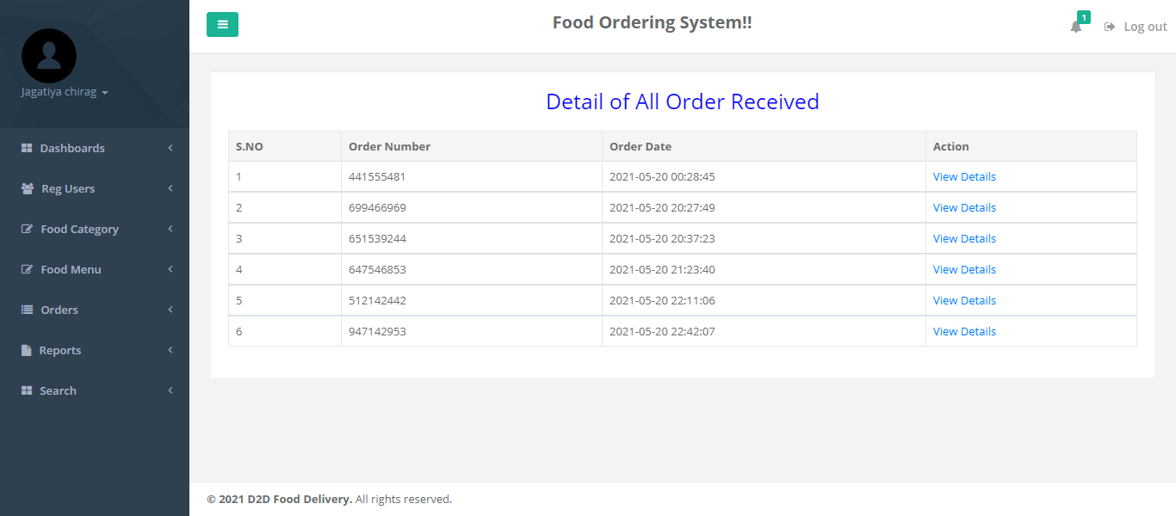

1. View Details Of All Order



1. B/W Dates Report

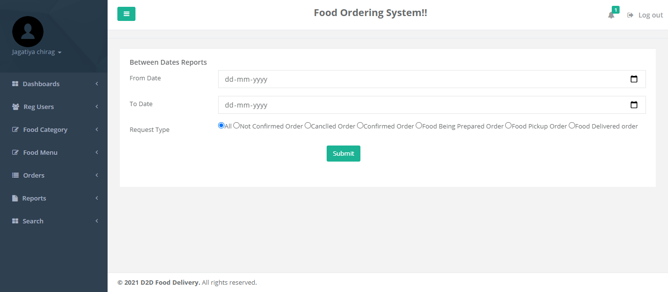

1. Details Of B/W Reports Dates

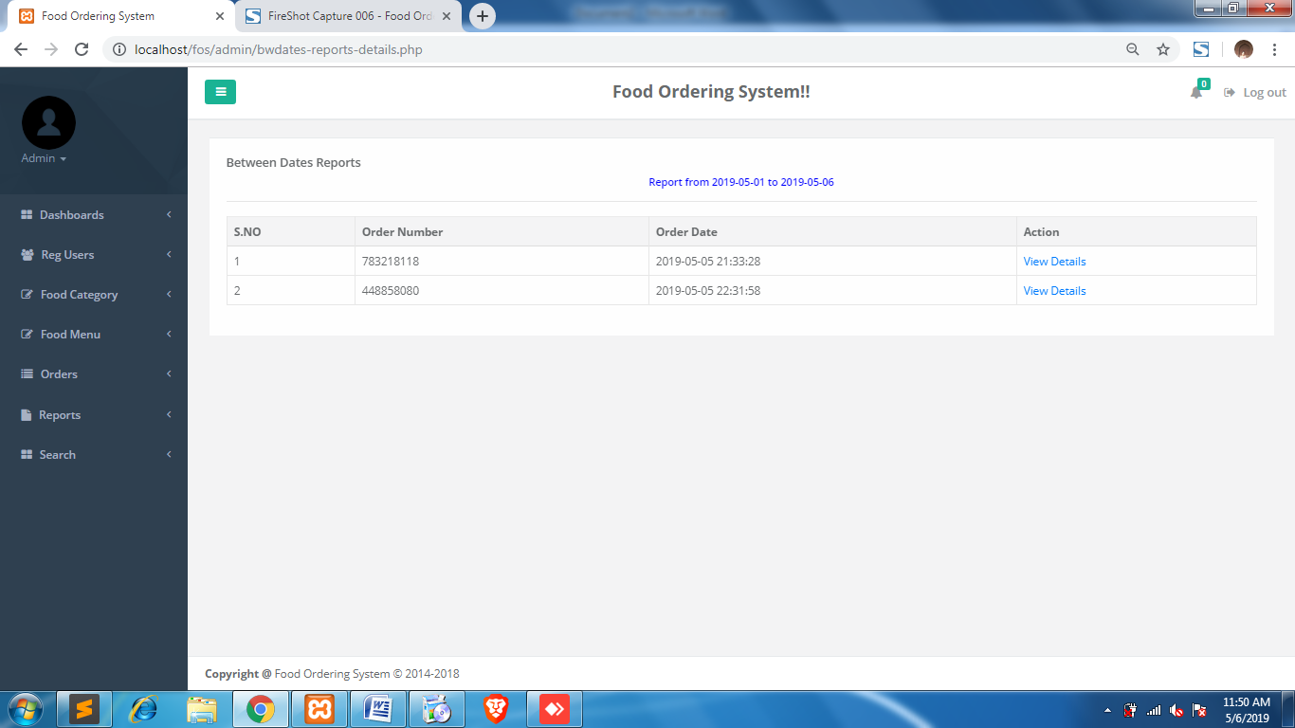

1. Order Count Report

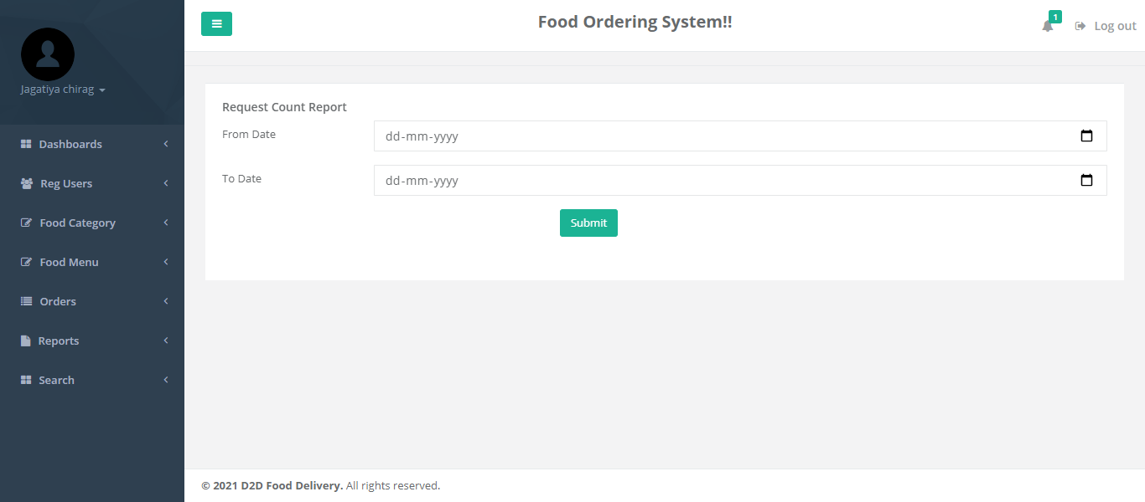

1. Sales Report

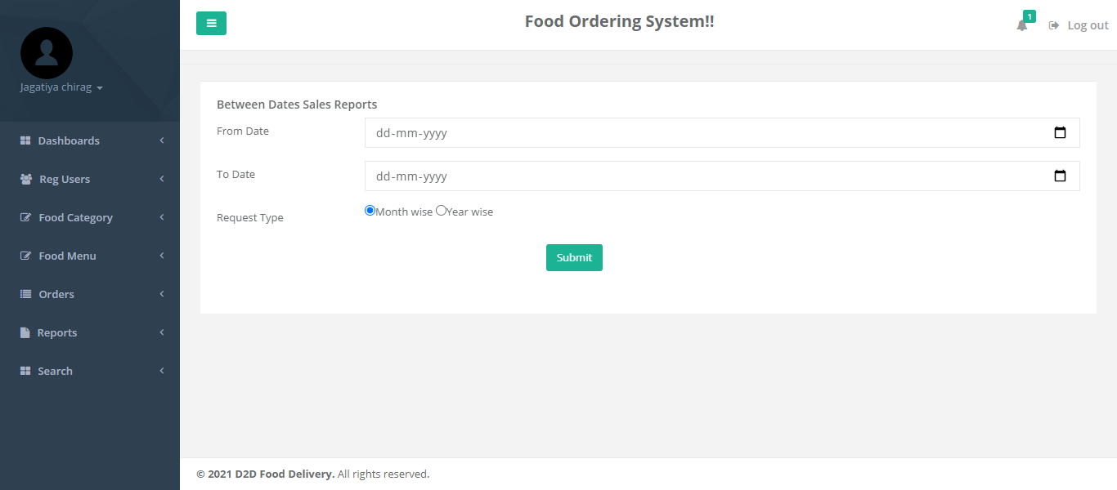

1. Details Of Sales Report

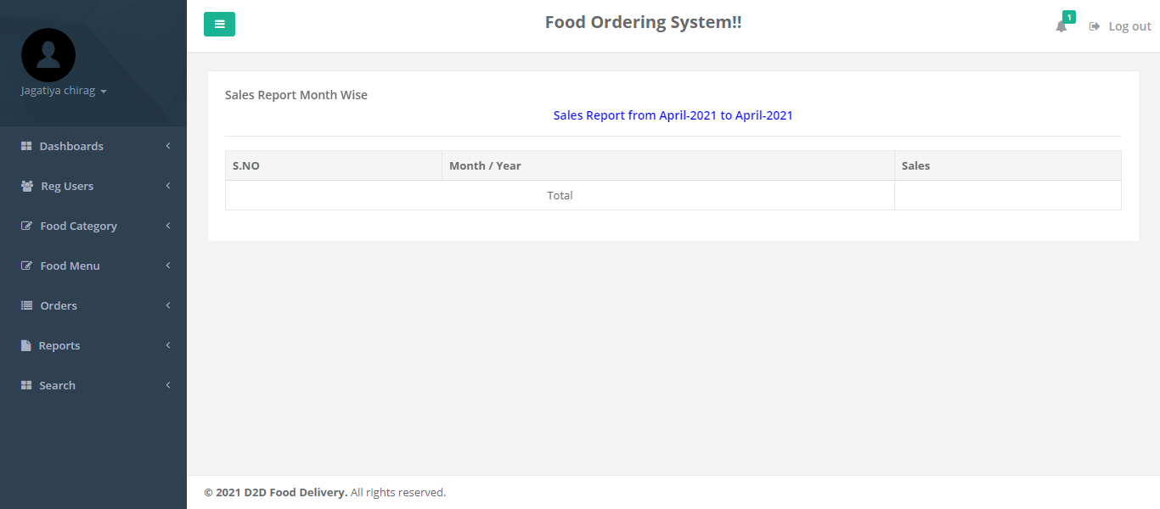

1. New Order Received

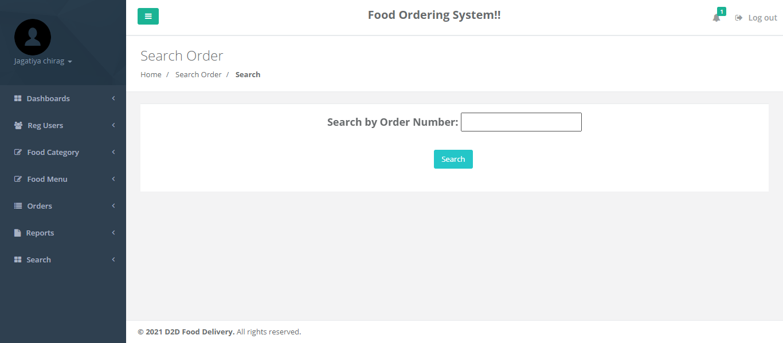

1. Search Order

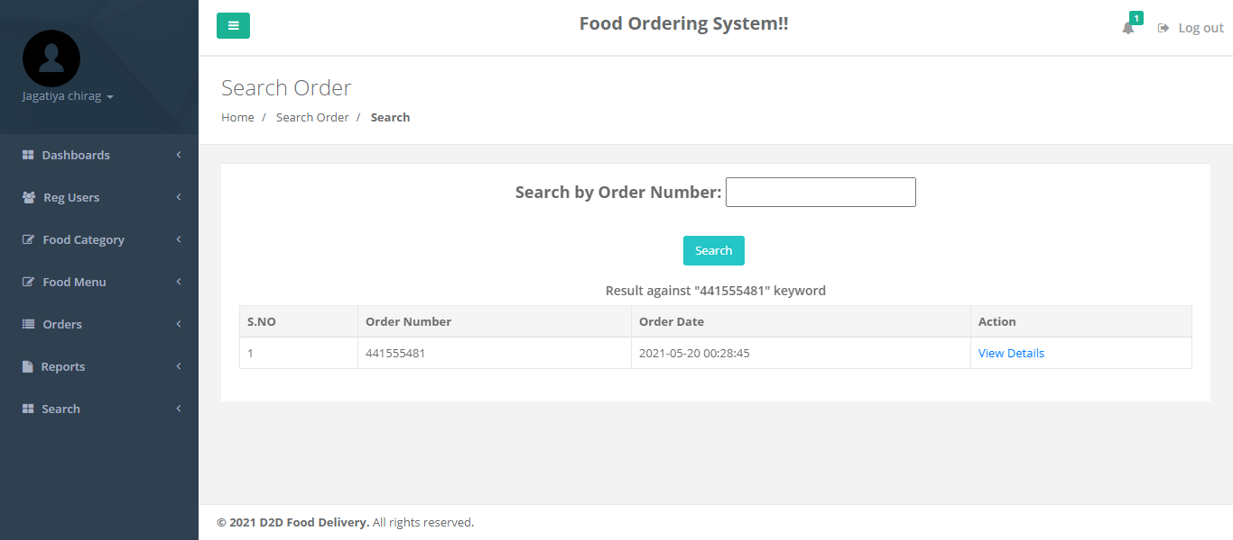

1. Forgot Password

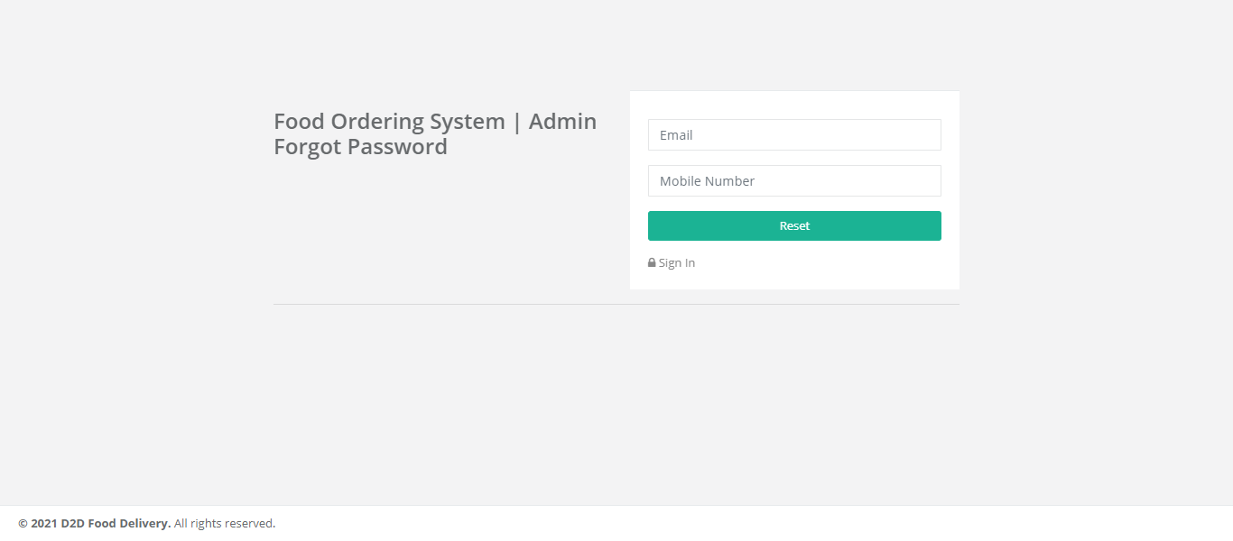

1. Resent Password

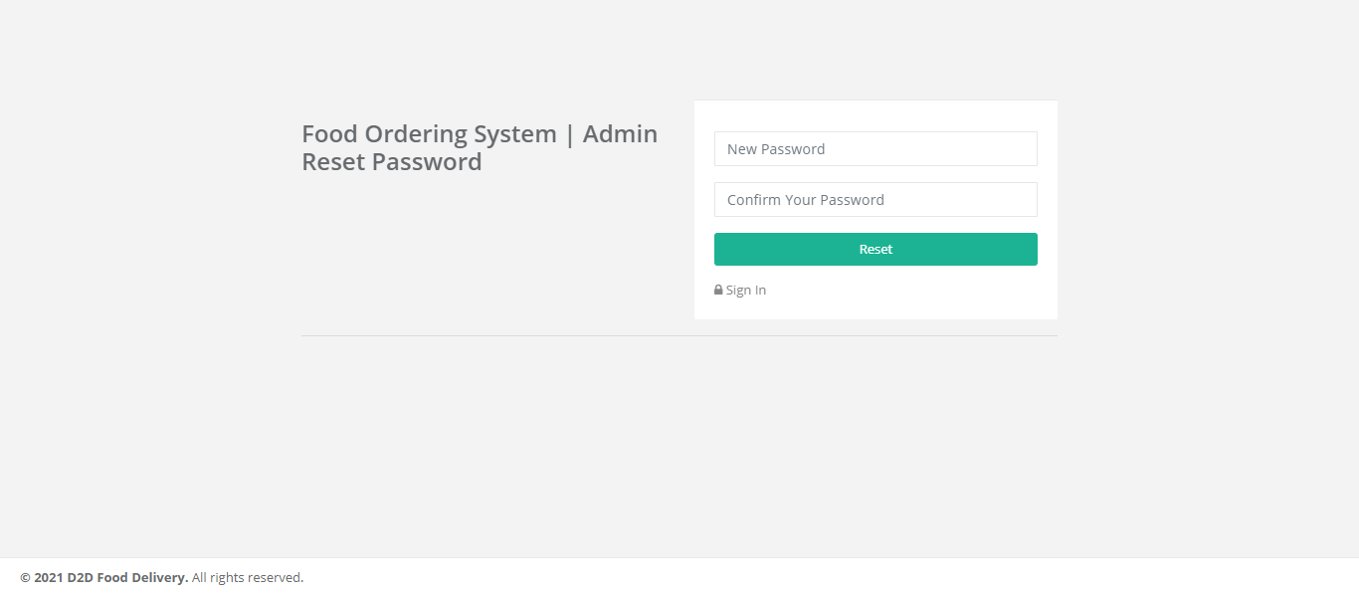

* Summary Of Result:-
* **Features:-**
* Easy Order Placement.
* Easy Payment Options
* Registration and login
* User Interface
* Conclusion & Future Scope

1. Conclusion:-

After a decade, the advancement and innovation of technology help people to manage their task easily and efficiently. In many other industry area have been used management system to assist their business grow long time ago, therefore it is also a trend that cause F&B industry to make use of a management system for their business. At the end of this project, the system can reduce and replace the human man power task, reduce the time consume for each transaction and generate report for further management purpose by fully utilizing the system.

1. Feature Scope:-

The Scope of the project (Android / web panel based application) are as follows: Food Ordering app can sale Food product, preferred brands, kitchen needs, essential restaurant supplies and more, through this online, one- stop Food store. It provides you with a convenient way to sale from your Food shopping app.